**A. KPI’s**

**1. Total Revenue:**

**select** **Sum**(***total_price***) **as** *Total_Revenue* **from** ***pizza_sales***

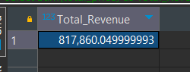

**2. Average Order Value**

**select SUM(*total_price*)/ COUNT(distinct(*order_id*)) as *avg_order_value* from pizza_sales**

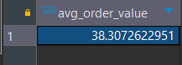

**3. Total Pizzas Sold**

**select SUM(quantity) from pizza_sales**



**4. Total Orders**

**select count(distinct(order_id )) from pizza_sales**

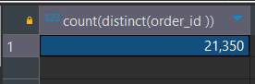

**5. Average Pizzas Per Order**

**SELECT CAST(CAST(SUM(quantity) AS DECIMAL(10,2)) /**

**CAST(COUNT(DISTINCT order_id) AS DECIMAL(10,2)) AS DECIMAL(10,2))**

**AS Avg_Pizzas_per_order**

**FROM pizza_sales**

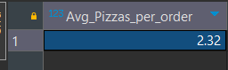

**B. Daily Trend for Total Orders  
 SELECT DAYNAME(STR_TO_DATE(order_date, '%d-%m-%Y')) AS order_day,**

**COUNT(DISTINCT order_id) AS total_orders**

**FROM**

**pizza_sales**

**GROUP BY**

**DAYNAME(STR_TO_DATE(order_date, '%d-%m-%Y'));**

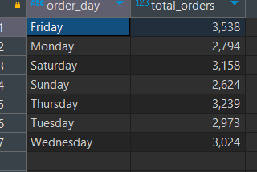

**C. Monthly Trend for Orders**

**SELECT monthname(STR_TO_DATE(*order_date*, '%d-%m-%Y')) AS *order_month*,**

**COUNT(DISTINCT *order_id*) AS *total_orders***

**FROM**

***pizza_sales***

**GROUP BY**

**monthname(STR_TO_DATE(*order_date*, '%d-%m-%Y'))**

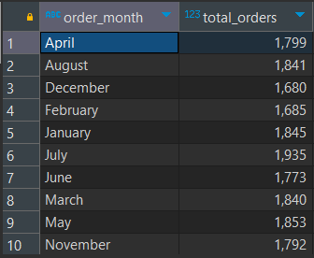



**D. % of Sales by Pizza Category**

**SELECT *pizza_category*, CAST(SUM(*total_price*) AS DECIMAL(10,2)) as *total_revenue*,**

**CAST(SUM(*total_price*) * 100 / (SELECT SUM(*total_price*) from *pizza_sales*) AS DECIMAL(10,2)) AS *PCT***

**FROM *pizza_sales***

**GROUP BY pizza_category**

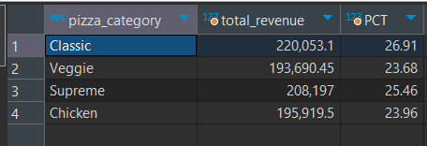

**E. % of Sales by Pizza Size**

**SELECT *pizza_size*, CAST(SUM(*total_price*) AS DECIMAL(10,2)) as *total_revenue*,**

**CAST(SUM(*total_price*) * 100 / (SELECT SUM(*total_price*) from *pizza_sales*) AS DECIMAL(10,2)) AS *PCT***

**FROM *pizza_sales***

**GROUP BY pizza_size**

**ORDER BY pizza_size**

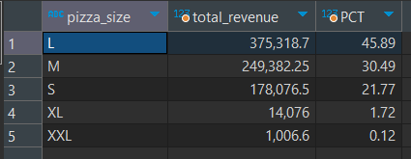

**F. Total Pizzas Sold by Pizza Category**

**select pizza_category, sum(quantity) as total_quantity_sold**

**from pizza_sales**

**group by pizza_category**

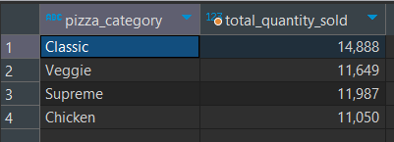

**G. Top 5 Pizzas by Revenue**

**select pizza_name,SUM(total_price) as total_revenue**

**from pizza_sales**

**group by pizza_name**

**order by SUM(total_price)desc**

**limit 5**

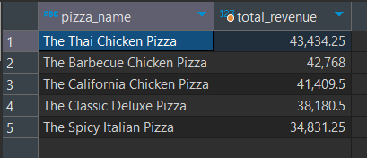

**H. Bottom 5 Pizzas by Revenue  
select pizza_name,SUM(total_price) as total_revenue**

**from pizza_sales**

**group by pizza_name**

**order by SUM(total_price)**

**limit 5**

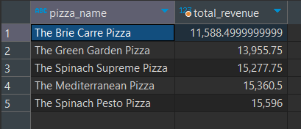

**I. Top 5 Pizzas by Quantity  
select pizza_name,Sum(quantity) from pizza_sales**

**group by pizza_name**

**order by Sum(quantity) desc**

**limit 5**

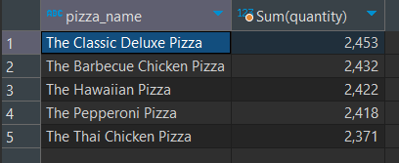

**J. Bottom 5 Pizzas by Quantity**

**select pizza_name,Sum(quantity) from pizza_sales**

**group by pizza_name**

**order by Sum(quantity)**

**limit 5**

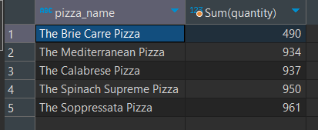

**K. Top 5 Pizzas by Total Orders**

**SELECT pizza_name, COUNT(DISTINCT order_id) AS Total_Orders**

**FROM pizza_sales**

**GROUP BY pizza_name**

**ORDER BY Total_Orders desc**

**limit 5**

**L. Borrom 5 Pizzas by Total Orders**

**SELECT pizza_name, COUNT(DISTINCT order_id) AS Total_Orders**

**FROM pizza_sales**

**GROUP BY pizza_name**

**ORDER BY Total_Orders asc**

**limit 5**

